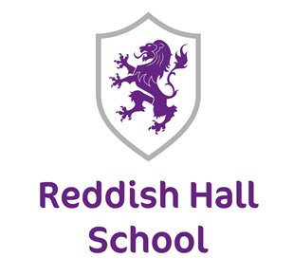
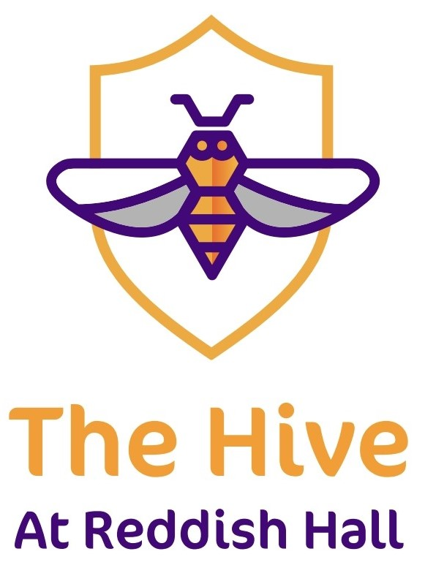

UNIFORM POLICY
Policy Number
Reviewed | December 2022
Review Date | December 2023
Owner-Name | Martyn Taylor
Owner- Job Title | Head of School
This policy should be read in conjunction with;
Promoting good behaviour and discipline

Reddish Hall School Anti-Bullying Policy
Rationale
We understand that many of our children have sensory needs that may make wearing certain items of clothing difficult for them, so we aim to be flexible in term of what is required.
Uniform is a key part of our school, giving a sense of belonging and identity. It ensures that children are wearing clothing that is suitable for the activities they will be carrying out and enables our pupils to be recognised easily when on educational visits while enabling parity with children from different socio-economic backgrounds.
It also provides the very first boundary within the school environment, and it is an expectation that children stay within this boundary, and parents and carers support them to do so. Children feel safer when firm boundaries are in place, and uniform is a visual symbol of a boundary for them.
We encourage our children to celebrate their individuality, however this has to be done within the constraints of what is suitable for school which is in effect a workplace.
The information below outlines what is acceptable and what is not.
Uniform for all pupils
Black trousers which may include:
- Traditional school trousers,
- Traditional school shorts,
- Black jeans (not faded or ripped),
- Black sweatpants,
- Thick black leggings (through which underwear cannot be seen),
- Black culottes ,
- Black skort which is no shorter than mid-thigh in length,
- Black skirts with suitable undershorts or high Denia black tights may be worn. Both skirt and shorts must be at least mid-thigh in length with the shorts not being visible when standing.
Although infrequent, physical interventions do take place. The school does insist that any pupil wearing a skort/skirt must be of the length with the suitable undershorts/tights as set out above to ensure that pupils and staff maintain dignity.
If a pupil regularly ignores the uniform policy in terms of length and/or undershorts/tights, this pupils option to wear this choice of uniform may be revoked.
Sweater, a jumper or fleece – two of these are provided for each pupil, each year. Additional ones can be bought from the school. Each choice will have the relevant emblem depending on which site the pupil is based, Reddish Hall or The Hive.
A white polo shirt or school shirt to be worn underneath the Reddish Hall sweater/jumper/fleece. The Hive use black polo shirts with The Hive emblem embroidered.
Suitable shoes or trainers that must be flat and not steel toe-capped.
Tie. Some of our children enjoy wearing this, as it makes them feel smart. Other children may find them restrictive, so this is an optional part of uniform, and must be requested.
Vocational students, due to the nature of their curriculum, need to wear one item from the uniform list above that makes them recognisable as a pupil of The Hive. This can be a polo shirt or any of the jumpers/tops listed above.
Key Stage 5 pupils are part of our Higher Education setting and as such are expected to wear smart casual clothing as they would in any other Higher Education/college setting. They can choose to wear a school uniform if they wish.

Hair styles
We encourage our children to show their individuality in sensible ways that will not result in them being teased and allow to understand what is accepted within a ‘work environment’. Hair colour and cuts are one way of showing individuality, as long as they are suitable for the child’s age cannot be considered offensive. It may be sensible for parents or carers to speak to school staff first. Extremely long hair will be required to be suitably tied back. Staff may advise on whether a hair style is suitable or not: please consult with school beforehand if you are unsure.
Make-Up
We understand that some of our pupils enjoy wearing make-up and it helps increase their self-confidence. Light make-up that would be suitable in an office situation is acceptable for school. This can include foundation, concealer, tidied eyebrows that look natural, light mascara or short false eyelashes, light contouring and blushers.
Nail polish
Polished nails are acceptable. False and acrylic nails are not permissible.
PE Kit
We ask children bring in a suitable change of clothes to do PE in. This includes leggings, a long T-shirt, shorts or sweatpants/joggers (although these could be too hot). All clothes must be appropriate to be used in school. Children will also need sensible footwear – trainers or pumps.
Science, Food Technology/Catering & Construction
There are specific expectations in these subjects for what pupils wear to keep themselves safe, or uphold hygiene requirements. Long hair must be tied back, and there may be specific clothing for pupils to wear, such as aprons or chef hats which will be provided by school. In construction, as a safety requirement, children must wear specific boots and overalls. These are provided by school. If a child refuses to wear such items, they will not be able to participate in specific activities. We will ask parents and carers to support us with this in encouraging their child to follow the rules.
Pupils will not be able to complete practical activities in food technology/catering if they are wearing nail polish, false nails, or not professionally applied false eyelashes. This is to comply with expectations around food hygiene.
Supporting pupils with uniform
We do understand that some pupils, for example, may use clothing as a comforter, such as a coat or a hoodie. Work will be carried out with the family and our family liaison team, and our therapy team, to support the young person to ‘fit in’ with the rest of the school.
What is not accepted
Open toed-shoes, sandals or flip flops – these are not safe in the school environment and activities in class
High heels – these are not safe in the school environment for activities carried out
Non-school hoodies or jumpers
Cycling shorts (can be worn as undershorts with a skirt)
Hair styles that may other children to make unkind comments
Make-up that is more suitable for night-time (thick eyeliner, heavy contouring, extremely long false lashes, foundation that is not blended into the skin’s natural colour, heavy eyeshadow)
False nails that are longer than 4mm over the finger- these present a health and safety hazard, and could cause harm to the child, other children or inhibit learning activities.

Parent and Carers Support and Responsibility
We rely on parents and carers to support us by ensuring their child is dressed appropriately for school in accordance with this policy, and we will do our best to support parents and carers with this.
If a child attends school not wearing correct uniform, we will contact the parents/carers to inform them. If incorrect uniform is worn on a third occasion in two week period, we will request that parents and carers come into school with the correct uniform for their child to change into, or transport the pupil home so they can get changed into correct uniform. If this becomes a persistent issue, then a meeting will be called with parents/carers to look at how they can be supported with these boundaries.
If a child attends school with clothing or make up that isn’t safe for the school environment, they will sit with a member of staff away from their peers with provided work until the issue has been rectified. This may require the parent/carer attending site to support with removal of false nails, provide suitable footwear etc.
If a child attends school wearing an item of clothing that may cause difficulties with behaviour or result in other pupils becoming heightened, the child will sit with a member of staff with provided work until the issue has been rectified.

